Unit Two: The Lithosphere

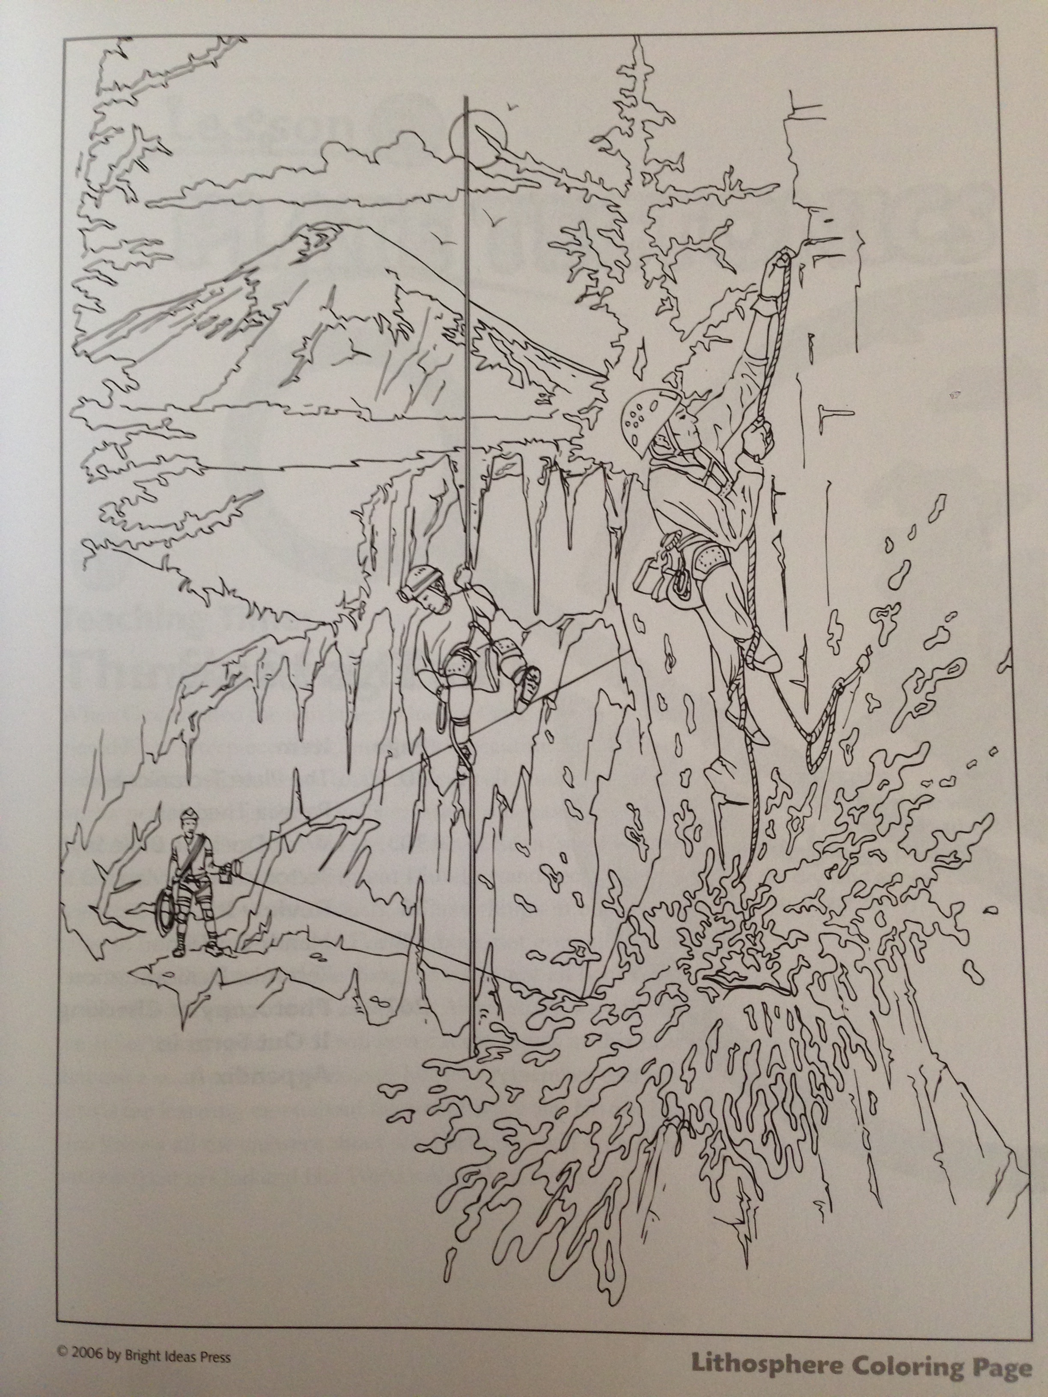
Lesson 3 Main Topic: _____________________________________________
“Then God said, ‘Let the waters under the heavens be gathered together into one place, and let the dry land appear;’ and it was so.” Genesis 1:9
Facts:
Three things that suggest that Pangea Theory and Plate Tectonics Theory might be true:

1. ____________________________________________________________________________________________

2. ____________________________________________________________________________________________

3. ____________________________________________________________________________________________

Vocabulary:
Plate Tectonics Theory: ____________________________________________________________________

Pangea Theory: _____________________________________________________________________________

My Thoughts:
I learned: ______________________________________________________________________________

I would like to know more about: ____________________________________________________
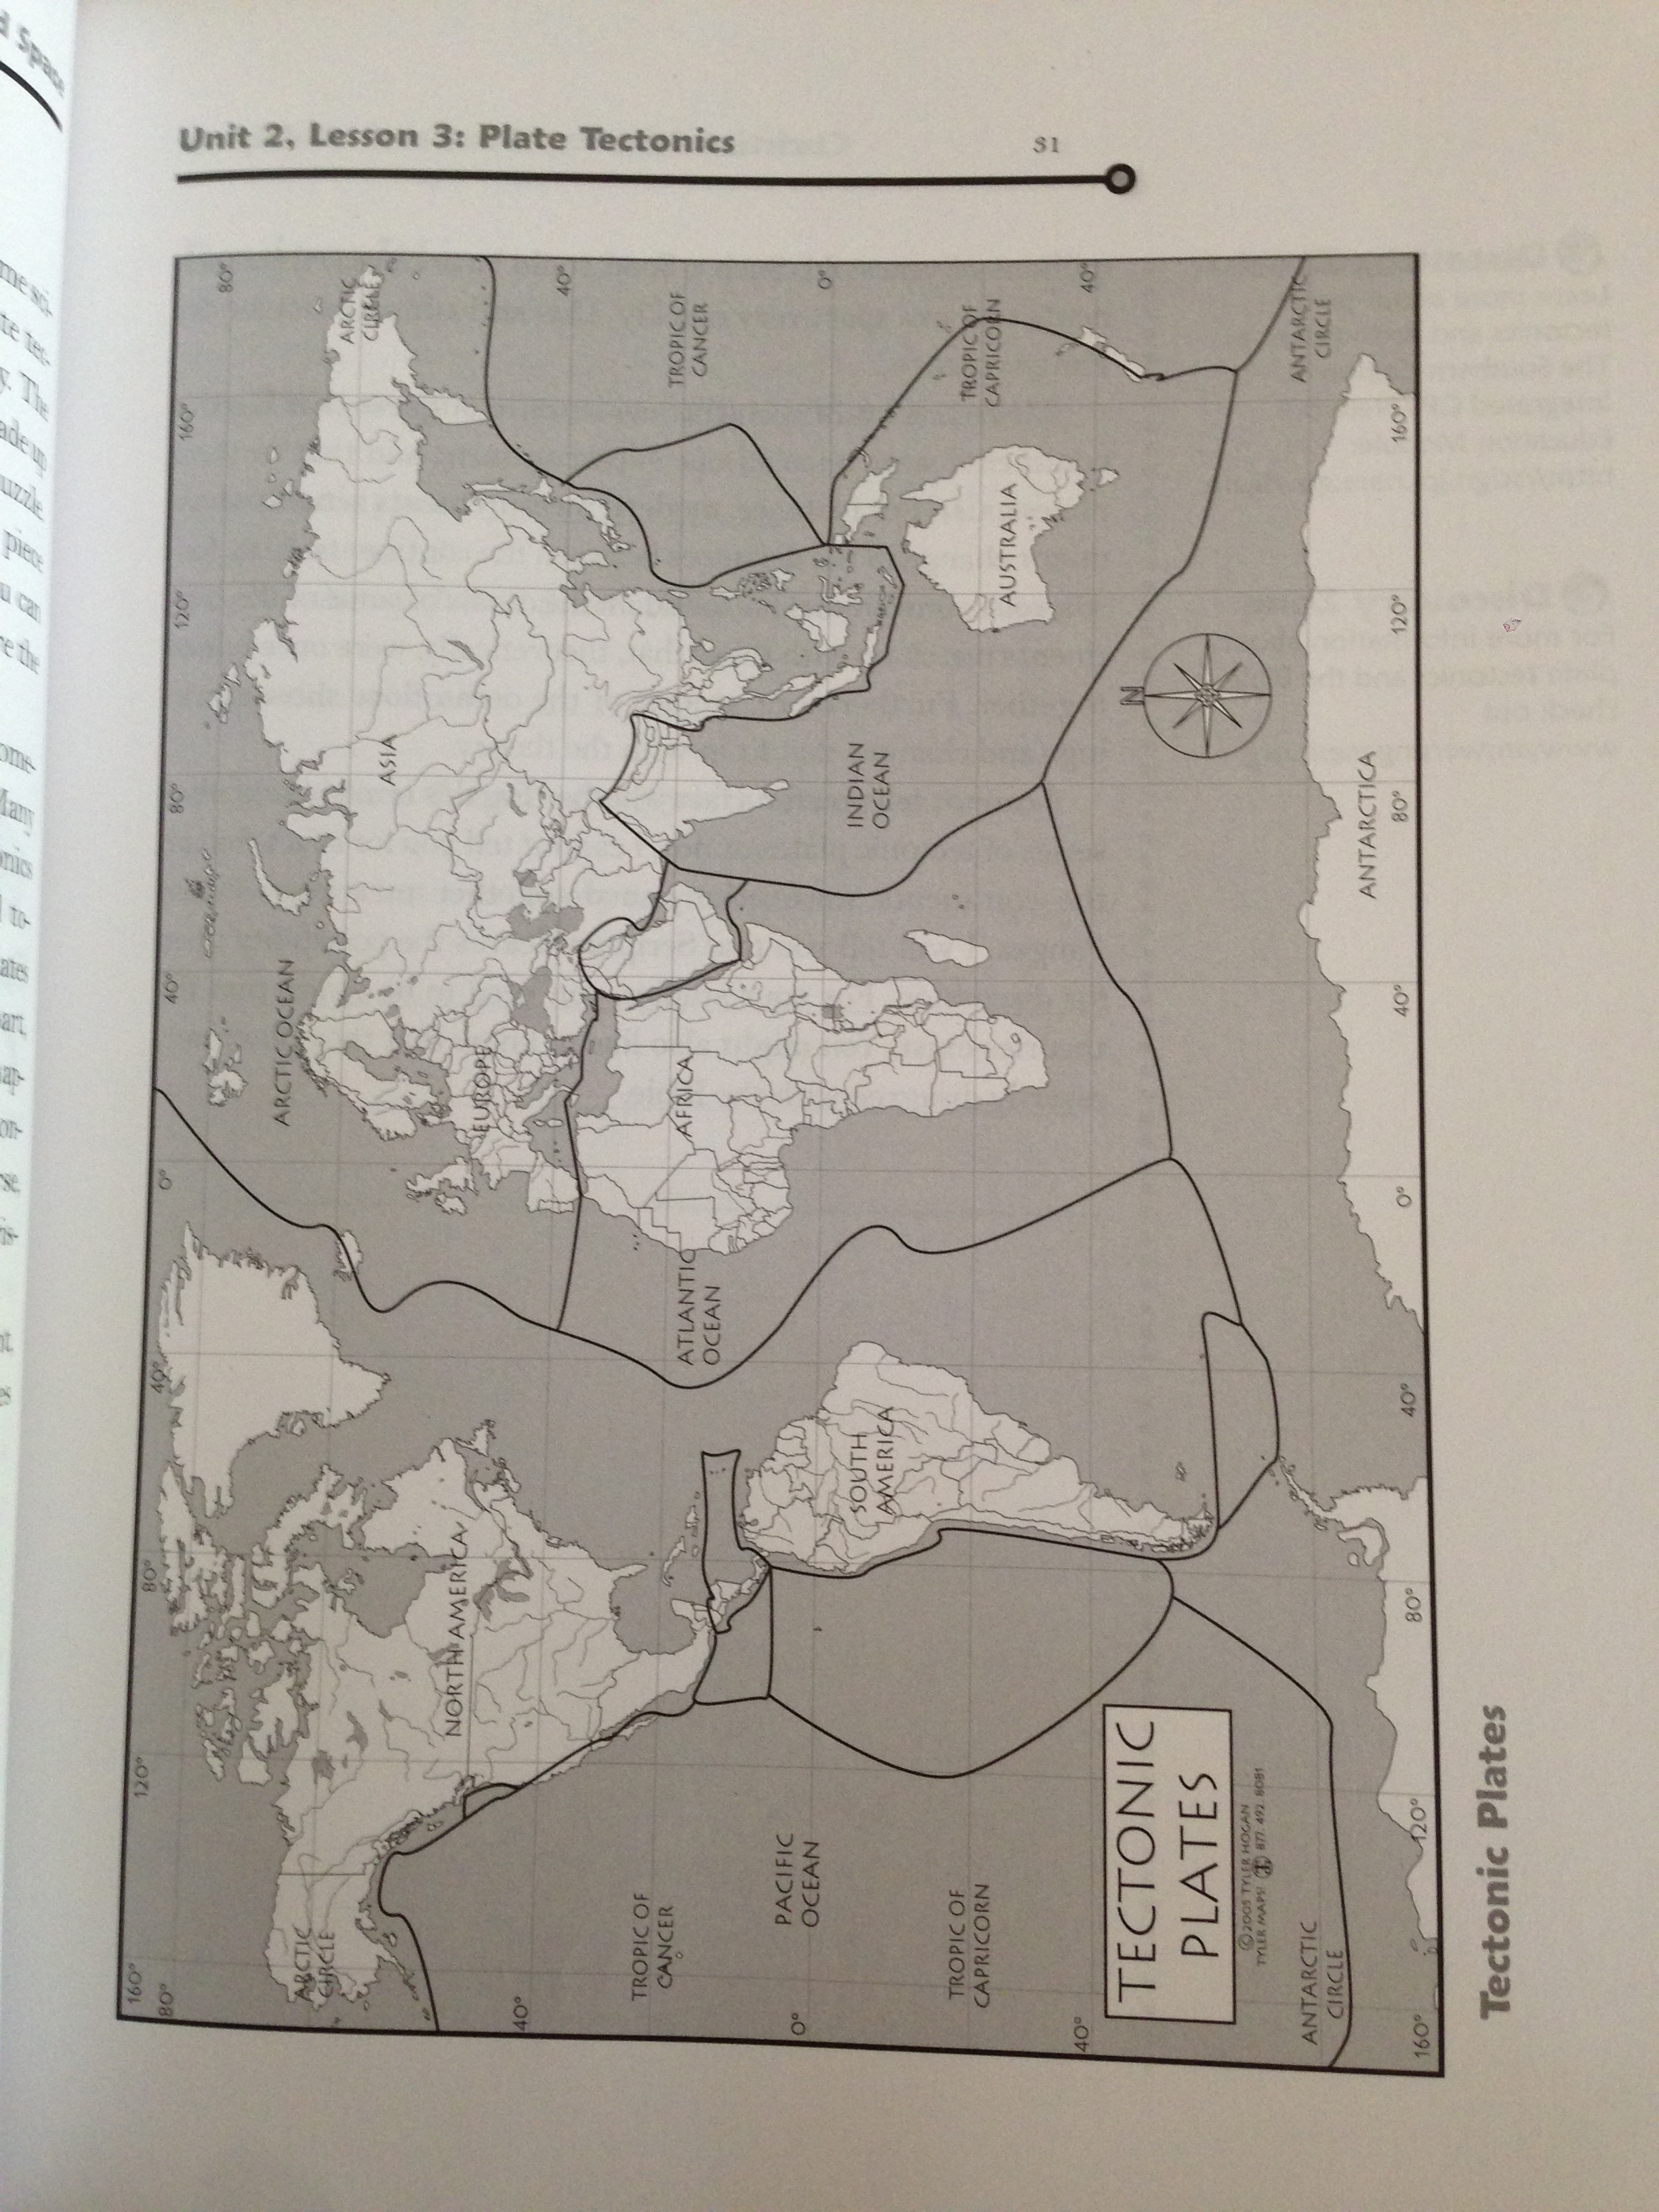
Lesson 4 Main Topic: _____________________________________________
“So he (Saul) came to the sheepfolds by the road, where there was a cave; and Saul went in to attend to his needs. (David and his men were staying in the recesses of the cave.)” 1 Samuel 24:3
Facts:
What are three different types of caves?

________________________ __________________________ __________________________

What are two types of acids that can form caverns?

__________________________ __________________________

What are the two types of speleothems?

__________________________ __________________________

Vocabulary:
Spelunking: _____________________________________________________________________________

Soluble: _________________________________________________________________________________

My Thoughts:
I learned: ______________________________________________________________________________

I would like to know more about: ____________________________________________________

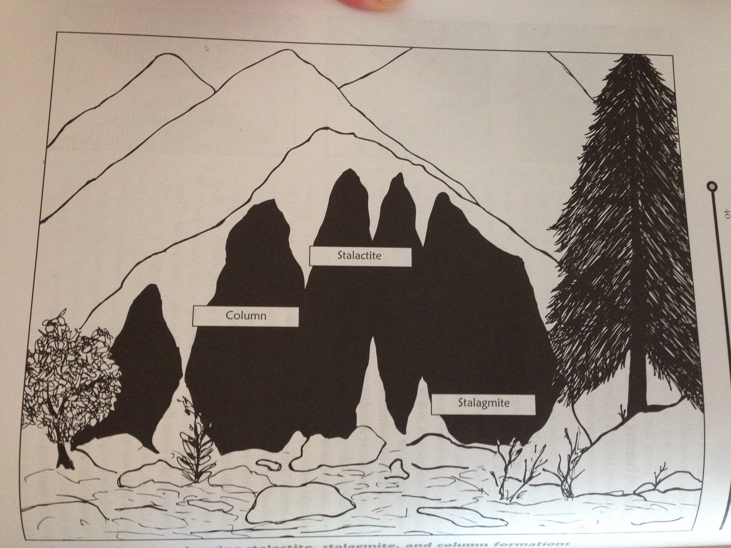
Make a speleothem:

- Pour 4 c of very warm water into a mixing bowl.
- Add Epsom salts, stirring continuously. Keep adding salts until no more can be dissolved.
- Divide the solution evenly between two jars and place in a sunny spot.
- Place a saucer between the two jars. Add a small amount of Epsom salts to the center of the saucer.
- Tie a paper clip onto each end of the yarn.
- Soak the yarn in the solution, then place each end of the yar in a jar so that the yard in connecting the two jars and the yarn is inside the solution in each jar and the center of the yarn dips lower than the water levels in the jars.
- Each day, observe the project and record your observations.

 | Day 1 | Day 2 | Day 3 | Day 4 | Day 5 | Day 6 | Day 7
Water level in inches
Formation on saucer? | Yes  No | Yes  No | Yes  No | Yes  No | Yes  No | Yes  No | Yes  No
Changes in Formation? | Yes  No | Yes  No | Yes  No | Yes  No | Yes  No | Yes  No | Yes  No
Sketch of formation

Lesson 5 Main Topic: _____________________________________________
“Like one who takes away a garment in cold weather, And like vinegar on soda, is one who sings songs to a heavy heart.” Proverbs 25:20
Facts:
What are four different categories of volcanoes?

__________________________ __________________________ __________________________ __________________________

The three volcanic conditions are:

__________________________, __________________________ , or __________________________.

How does a volcano form?

Vocabulary:
Volcanologist: _____________________________________________________________________________

Magma: _________________________________________________________________________________

My Thoughts:

I learned: ______________________________________________________________________________

I would like to know more about: ____________________________________________________

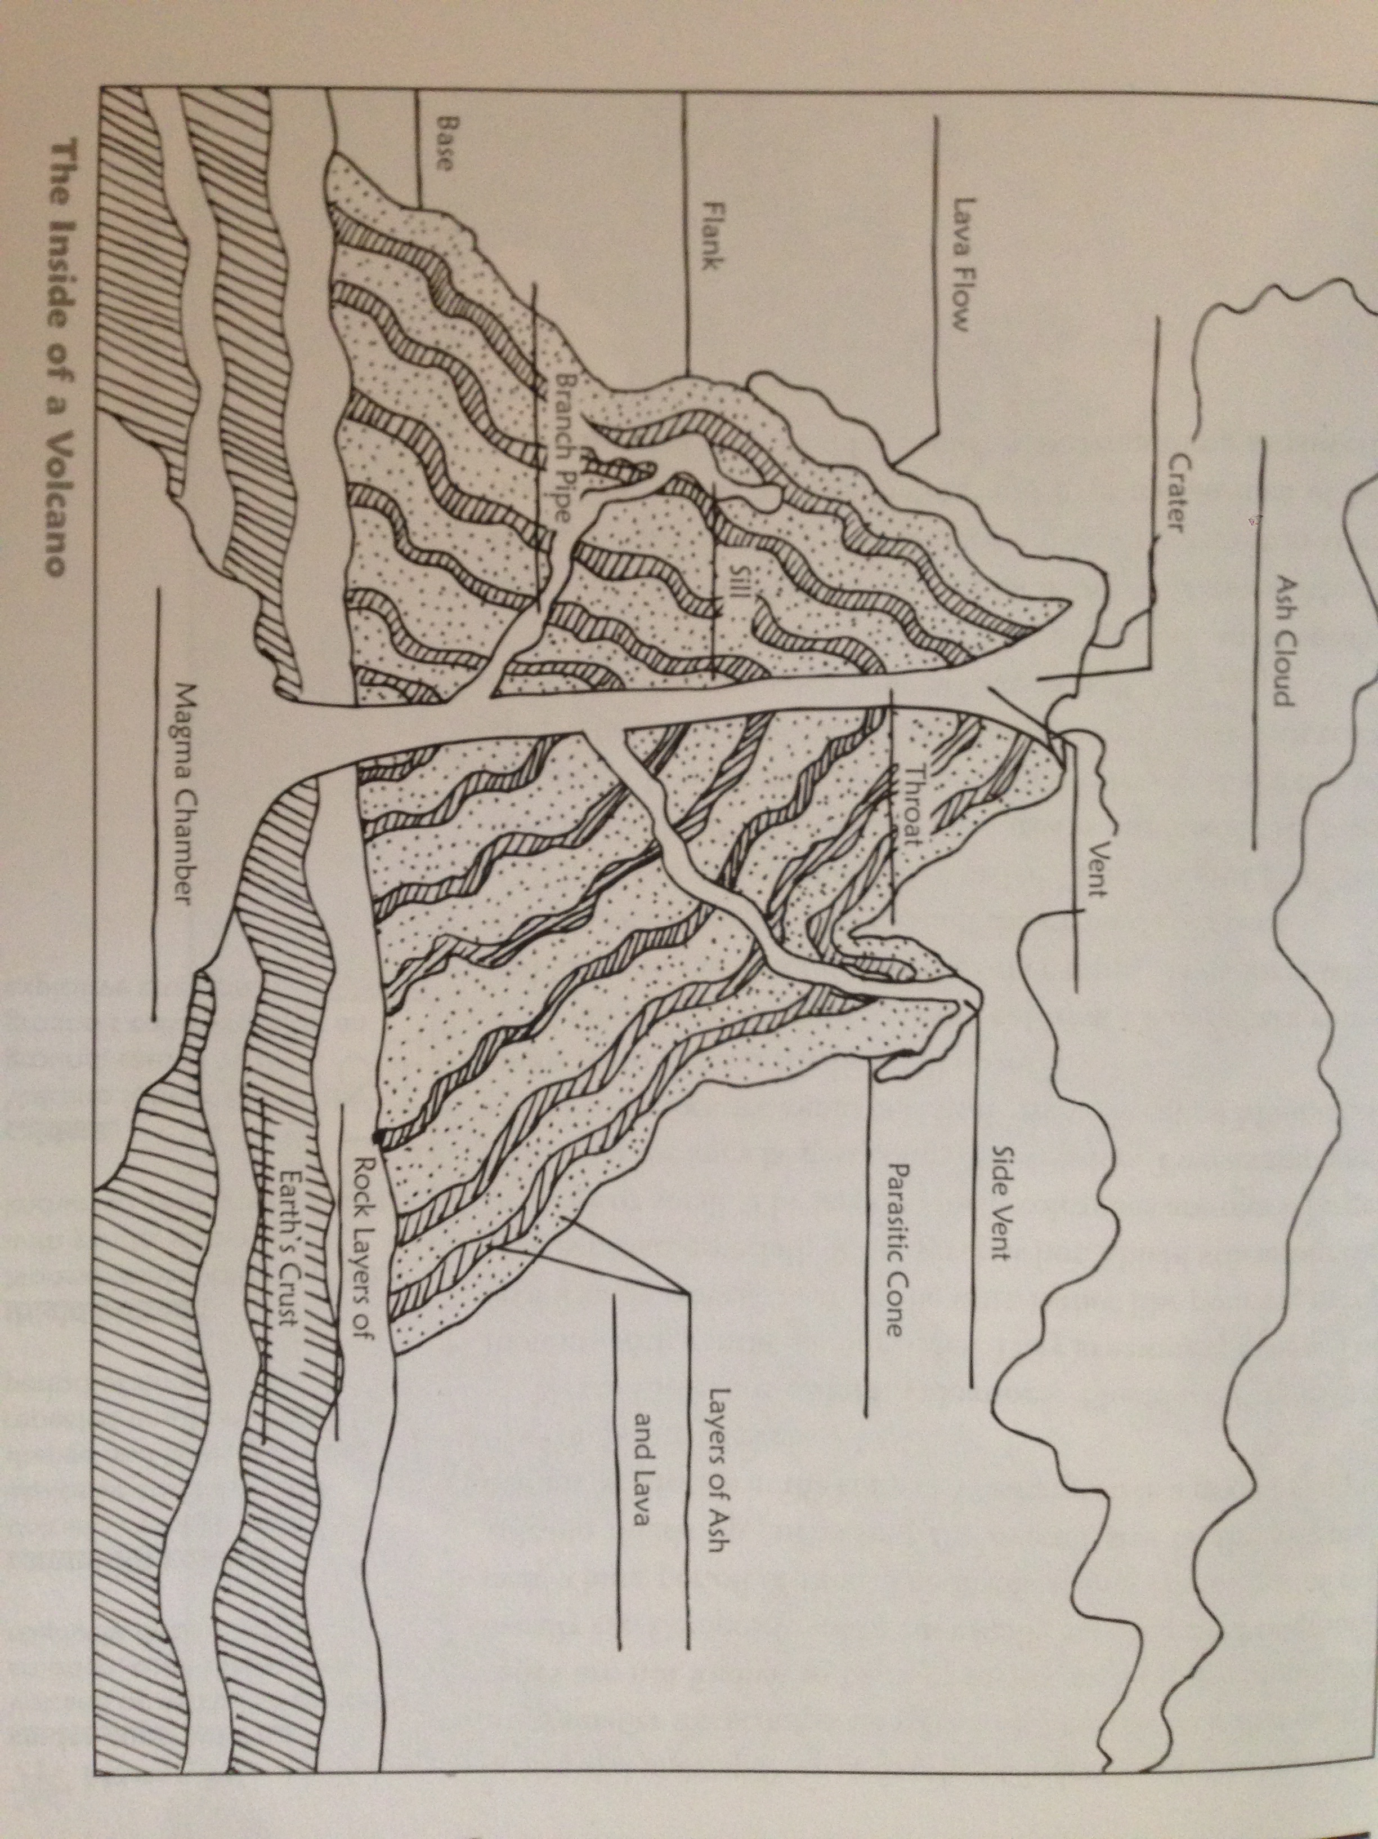
EXPERIMENT:

- Cover table or countertop with a vinyl tablecloth, then put a 16 oz clear plastic bottle on a piece of cardboard/plywood.
- Use a funnel to add 3-4 T baking soda to the bottle.
- Add 3-4 drops of dishwashing detergent.
- Slowly add ½ cup water.
- Slowly add ½ c vinegar & orange food coloring mixture to the bottle.

Lesson 6 Main Topic: _____________________________________________
“Then, behold, the veil of the temple was torn in two from top to bottom; and the earth quaked, and the rocks were split…” Matthew 27:51
Facts:
Who invented the seismograph?

________________________ __________________________

Name one fault in the United States.

Vocabulary:
Seismology: _____________________________________________________________________________

focus: _________________________________________________________________________________

epicenter: ______________________________________________________________________________

My Thoughts:

I learned: ______________________________________________________________________________

I would like to know more about: ____________________________________________________

Write About It: Write a short story about an earthquake.

Lesson 7 Main Topic: _____________________________________________
“Some fell on stony places, where they did not have much earth; and they immediately sprang up because they had no depth of earth.” Matthew 13:5
Facts:
What are three different categories of rocks?

________________________ __________________________ __________________________

What are the two types of igneous rock?

__________________________ __________________________

What are three types of sedimentary rocks?

__________________________ __________________________ __________________________

Vocabulary:
Rocks: _____________________________________________________________________________

Geologist: _________________________________________________________________________________

My Thoughts:

I learned: ______________________________________________________________________________

I would like to know more about: ____________________________________________________

Hardness Rating | Mineral | Rating “Definitions”
1 | Talc | 1-2: Can scratch with a fingernail  2-3 Can scratch with a copper coin  3-6: Can scratch with a steel pocket knife  6-7 Will not scratch glass  8-10 Will scratch glass
2 | Gypsum
3 | Calcite
4 | Fluorite
5 | Apatite
6 | Orthoclase Feldspar
7 | Quartz
8 | Topaz
9 | Corundum
10 | Diamond

SNACK!

Make Rock Snacks

- Melt ½ c butter in a small pan and pour into a 13x9 baking pan.
- Sprinkle 1 ½ c Vanilla Wafer crumbs over the butter
- Pour 1 rox can sweetened condensed milk over the crumbs.
- Layer 1 6 oz package of chocolate chips, 1 6 oz package peanut butter chips,a nd 1 cup shopped walnuts or pecans evenly over the top.
- Press down gently. Bake at 350 for 25-30 minutes.
Unit Two Wrap Up

Match:

1. The theory that states that the Earth’s crust is made of plates that are in constant motion | a) Lava
2. The theory which states that the continents of Earth were once all joined. | b) Faults
3. The cave formation that forms on the ceilings of caves | c) stalagmite
4. The speleothem that forms on the ground of caves | d) Sedimentary rocks
5. A combination of molten rock, gas, ash and rock from inside Earth | e) Plate tectonics theory
6. The instrument that scientist John Milne invented | f) Stalactite
7. Cracks in Earth’s tectonic plates that are responsible for earthquakes | g) Magma
8. Rocks that form from cooled magma | h) Seismograph
9. This forms when loose sediments deposited from moving water builds up in layers that harden together | i) Igneous rocks
10. Rocks whose structure has changed as a result of high temperatures and pressure | j) Metamorphic rocks
11. What magma is called when it flows out of the ground | k) Pangea

Write About It: What was the coolest thing you learned in Unit Two?

